

1530 CENTER STREET.
TACOMA, WA 98409
P (253) 327-1530

www.contourcountertops.com
EMAIL FORM TO: STONEANDQUARTZ@CONTOURCOUNTERTOPS.COM

STONE COUNTERTOP QUOTE WORKSHEET
Complete the following worksheet and attach your cabinet layout and countertop measurements and fax your quote request to Contour Countertops. A written quote will be e-mailed or returned faxed to you for your reference.

Customer Information:

Name: ________________________________________________ Source: ___________________________
Mailing Address: ___________________________________________________________________________
Day Time Phone: _______________________________________ Fax #: ____________________________
Jobsite Address: ___________________________________________________________________________

Project Information: (please check all that apply)
Kitchen Bath Other
( ) Countertops ( ) Vanity ( ) Mantle
( ) Island ( ) Desk
( ) Eating Bar ( ) Other ___________________

Countertop Material: (1 ¼” Thick)
( ) Stratus Quartz Color Name: ___________________________________ Color #: ____________

( ) ______________ Color Name: ___________________________________ Color #: ____________

( ) ______________ Color Name: ___________________________________ Color #: ____________

( ) Granite Color Name: ___________________________________ Color #: ____________

Edge Profile (1 ¼”): (check box for edge profile)

BASIC
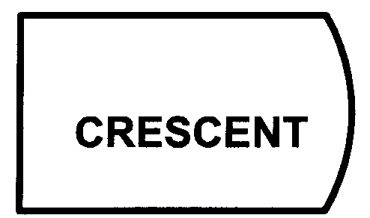


( ) Flat Polish
STANDARD PREMIUM
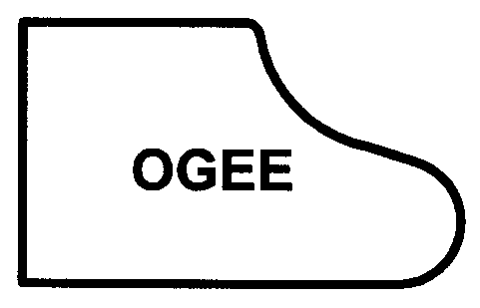

( ) Bullnose ( ) Round ( ) Crescent ( ) Ogee

Backsplash Height: (1 ¼” Thick)
( ) Standard 4” ( ) None ( ) Other – specify height _______________

Sink Information: ( ) Top mount ( ) Undermount ( ) Farmhouse
( ) Stainless Steel ( ) Cast Iron Other ____________________

Range Type:
( ) Free Standing ( ) Cooktop ( ) Slide-in or Drop-in, countertop behind range

Existing Countertop Removal:
( ) Yes ( ) No If Yes, What type? ( ) Laminate ( ) Tile ( ) Stone ( ) Other __________________

Quotes are based on information supplied by you. All projects require a jobsite template to verify dimensions, design details, and price prior to fabrication. All cabinets must be permanently secured in place prior to the template. Price is honored for 45 days from the quote date.

We do not do any plumbing, electrical, cabinet, or wall repair work.

STONE COUNTERTOP LAYOUT FORM

Name: _____________________________________________________________________

If you have a cabinet layout drawing, include it with your Quote Worksheet and this layout form.

If you are measuring your existing countertops, draw your project layout using this form and include it with your Quote Worksheet.

Refer to the sample layout drawing for examples.

Drawing Instructions

- Use the following symbols to indicate finished edge and backsplash
“X” – Finished Edge “======”(double line) – Back/side splash

- Provide all back wall dimensions

- Indicate location of all appliances

- Specify any window extensions or sills, include depth and length

- Specify any special details for the project

Location: I drive/FORMS
